Name: Date: Long (i) as y

The long (i) sound is most often represented by the letter y when it comes at the end of words, like in the words below.

Remember: Say the word aloud, then say each letter aloud as you write it e.g. 'why, w ... h ... y'

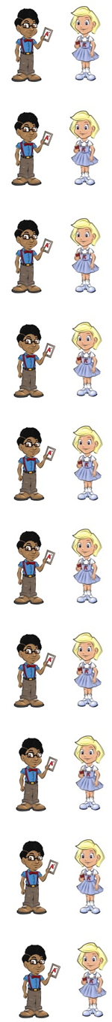
If you tell someone why, you give them a reason.

If you are upset, you might cry.

You dry things with a towel.

If you fry something, you cook it in oil.

You should always try to do your best.

The sky can be clear or cloudy.

A bird can fly by using its wings.

If you spy on someone, you watch them in secret.

If someone is shy, they do not talk much.

If you apply (ap/ply) for something, you ask to join.

Now test yourself without looking at the words and check for yourself if you got them all right. Practice writing any words that you made mistakes on again.

© www.SaveTeachersSundays.com 2013
Name: Date: Long (i) as y

The long (i) sound is most often represented by the letter y when it comes at the end of words, like in the words below.

Remember: Say the word aloud, then say each letter aloud as you write it e.g. 'why, w ... h ... y'

Try to spell each word without looking at it.

If you tell someone you give them a reason.

If you are upset, you might .

You things with a towel.

If you something, you cook it in oil.

You should always to do your best.

The can be clear or cloudy.

A bird can by using its wings.

If you on someone, you watch them in secret.

If someone is , they do not talk much.

If you for something, you ask to join.

Now check for yourself if you got them all right. Practice writing any words that you made mistakes on again.

© www.SaveTeachersSundays.com 2013

